

EnerVistaTM Viewpoint Monitoring v7.20

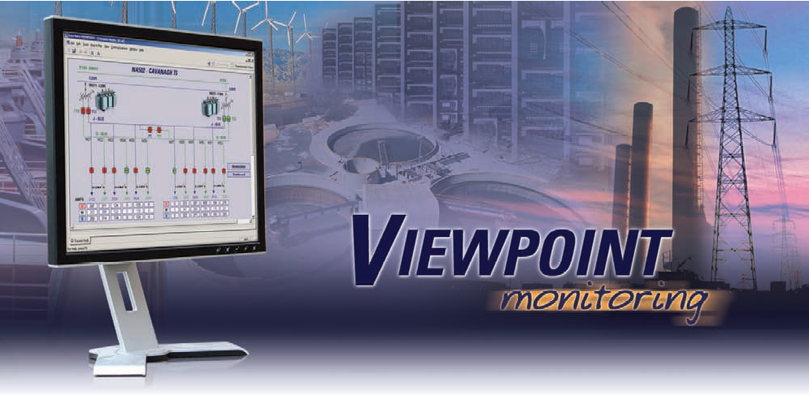

Guideform Specifications

April 2015

1 - Product Overview

1.1 Viewpoint Monitoring Scope
EnerVista Viewpoint Monitoring is an easy to setup, powerful and simple to use monitoring and data recording software application for electrical systems.
With minimal configuration required to communicate with field devices directly, Viewpoint Monitoring provides an overall view of the entire power system collects critical real-time and historical disturbance data to assist with analyzing past or impending power system events.

Viewpoint Monitoring is an easy to use software package that can provide monitoring and control for power systems containing up to 1000 devices (20000 data points) or 5000 devices (65000 data points) that use Modbus TCP/IP or Modbus RTU communications protocol.

This system is ideal for installations that require:
- A monitoring system with an easy, pre-configured setup with little customization
- 24x7 Monitoring, Control and Data Recording of a power system
- On-Demand status monitoring of the status of devices in their small system

Viewpoint Monitoring is a stand-alone software package that can be installed on a single workstation that has both the communications server and the HMI built into the application.
This application does not require additional software or separate workstations for it to function.

Viewpoint Monitoring provides the following functionality:
- Pre-configured monitoring screens for GE Multilin Devices (Plug-and-Play)
- Single-Line Monitoring of power system devices
- Real-Time control of power system devices (Open/Close Breaker)
- Annunciator Alarming on monitored Analog or Digital points
- Trending of up to 5000 different device parameters with 1 minute resolution
- Automatic download of Events from GE Multilin Devices
- Sorting and Searching of Device Events in a system wide Sequence of Events Record
- Automatic Downloading of Waveforms from GE Multilin Devices
- Merging and Overlaying waveforms recorded in different power system devices
- Converting Waveforms stored in Comma Separated Values (.CSV) format to COMTRADE format files
- Viewing COMTRADE format waveform in Time Based, Phasor Value and Harmonic Content formats
- Configurable security functionality that limits access and functionality to many different levels of users

1.2 System Project Size
EnerVista Viewpoint Monitoring can provide Monitoring, Control and Data Recording for power systems that contain up to 1000 devices (20000 data points) or 5000 devices (65000 data points) that can communicate using the standard Modbus TCP/IP and Modbus RTU protocol.

1.3 Multiple User Terminals
If there is a requirement for multiple users to view the data in Viewpoint Monitoring from different locations on their network, using Terminal Services in Microsoft Windows Server 2008, separate installations of EnerVista Viewpoint Monitoring may be installed on different PC terminals or EnerVista Viewpoint ViewNodes can be used.

Microsoft Server 2008

Up to four remote access clients can view data in Viewpoint Monitoring using Remote Terminal Services in Microsoft Server 2008 systems.

Separate installations of EnerVista Viewpoint Monitoring

Each EnerVista Viewpoint Monitoring installation will have its respective communication server performing data collection and respective HMI.

EnerVista Viewpoint ViewNodes

EnerVista Viewpoint ViewNodes will connect to an EnerVista Viewpoint Monitoring installation to remotely monitor Viewpoint Monitoring. EnerVista ViewNodes provides the following functionality:

- Connect remotely to a Viewpoint Monitoring system over a network
- Implement security access by thorough user accounts with configurable permissions
- Provide complete access to:
  - Plug-and-Play screens
  - One Line diagrams
  - Annunciator Panels / Trending Reports
  - Events
  - Waveforms
- Connect up to 10 ViewNodes to a single Viewpoint Monitoring system

2 - Communications

2.1 Preconfigured Communications for GE Multilin Devices
EnerVista Viewpoint Monitoring connects to GE Multilin devices using Modbus over RS-232, RS-485, or Ethernet.

A list of GE devices that are preconfigured for use in the EnerVista Viewpoint Monitoring is provided in Appendix A – Supported Devices.

2.2 Third Party Devices

The memory maps for other non-GE Multilin devices that use the Modbus TCP/IP or Modbus RTU protocol can be added to Viewpoint Monitoring and used in the Single-Line Diagrams, Annunciator Alarms, and the Trending Reports.

The following Modbus data formats for reading memory map locations are supported:

Data Type | Description
Enumeration | Unsigned 16 Bit Integer (must configure enumeration list)
Floating Point | Floating Point (32 bits)
SINT16 | Signed 16 Bit Integer
SINT32 | Signed 32 Bit Integer (2 registers)
UINT16 | Unsigned 16 Bit Integer
UINT32 | Unsigned 32 Bit Integer (2 registers)
BIT | Signed 16 Bit Integer (Must define bit location)
HEX2 | Hex 2 Bytes - 4 ASCII Digits
COIL_BIT | Read Coil Status
INPUT_BIT | Read Discrete Input Status

The following Modbus data formats for forcing Coils are supported:

Data Type | Description
Force Coil | Function Code 5 – Only writing value of “1” is supported

3 - Monitoring

3.1 Monitoring Capability
- Monitor up to a total of 1000 devices (20000 data points) or 5000 devices (65000 data points)
- Create links to multiple screens to allow viewing of additional information on different parts of your power system.
- Create alarms on a metered analog or digital point.
- Drop in images or icons to tailor the view of your screens to your application.

3.2 Control Capability
Commands may be sent to a device that can accept a Modbus Force Coil command. GE Multilin products accept these commands by changing the state of Virtual Inputs where applicable.

The sending of commands requires a 2-step process that must be completed before the command is sent to the device to add extra security and eliminate the chance for mistakes.

3.3 Plug-and-Play Monitoring

Instantly View Device and Asset Monitoring Screens
EnerVista Viewpoint Monitoring’s Plug and Play screens are a series of pre-configured modules for analyzing the health and status of your power system equipment.

Auto-Discovery of UR Devices
Viewpoint Monitoring reduces integration time and decreases errors when configuring devices by automatically detecting and configuring UR devices. Viewpoint Monitoring will detect the devices you are using and automatically generate pre-configured monitoring screens that are tailored to your devices as well as wiring configurations.
Pre-configured Screens – ViewPoint Monitoring provides pre-configured screens for GE Multilin devices that display monitoring data with no programming required.

Data is displayed in easy to understand graphical components such as gauges, dials, phasor diagrams, bar graphs and device front plate simulations for easy understanding.

Device Monitoring Screens include the following data:
- Volts
- Amps
- Frequency
- Watts
- VARs
- VA
- Power Factor (PF)
- Demand
- Motor Temperature
- Thermal Capacity
- Symmetrical Components
- Trip Data

3.4 Simple Powerful One-Line Viewer and Editor

EnerVista Viewpoint Monitoring provides a perspective on the status of the entire power system and the magnitude of power levels on a configurable One-Line screen.

The One-Line Screen supports navigational links to navigate through more single line and device monitoring screens that will display more detailed specific information.

Plug-and-play screens and system diagrams are customizable to show analog or digital information from multiple devices on a screen at one time in a drag and drop interface.

The screen editor contains many preconfigured gauges, dials bar graphs and symbols to support fast and easy system diagrams creation.

3.5 Formula Editor
Customized Formulas may be created to create specific logic within a device or multiple devices using the Formula Editor. Analog points can be used to create customized mathematical formulas using parameters within a device or between multiple devices. Mathematical operations available include addition, subtraction, multiplication, division, sin, cos, tan, arcsin, arccos, arctan, exponents and absolute value.

Similarly, Digital points can be used to create custom formulas within a device or between multiple devices using the following Boolean Logic operands: OR, AND, XOR, NOT.
4 - Annunciator Alarming

4.1 Alarming Capability

Viewpoint Monitoring Annunciator Alarming actively monitors measured values and generates alarms.

Alarms can be configured to be activated whenever:
- a digital status changes state,
- an analog value changes beyond a programmed threshold

Alarms can be delivered through multiple through visual, audio, or e-mail notification channels. Furthermore the Monitoring and Alarm Sentry ensures annunciators and alarms are always active.

4.2 Visual Notification
Monitored points can be displayed on an easy to identify screen that shows the current status of the monitored point. As Alarm states occur, the alarmed point will flash in a color chosen by the user until the Alarm is acknowledged by the Operator. When analog monitored points are in the alarm state, the Annunciator will show the maximum/minimum value that the monitored point reached.

4.3 Audio Notification
Two levels of Audio notification are available, Alert Status and Alarm Status. Separate audio notiifcation sounds can be chosen for each noticification level. The audio notification of Alarms and Alerts will continue until the Alarm state is Acknowledged by the Operator.

4.4 Email Notification
If an email client is installed on the monitoring computer, the alarming of a monitoried point can automatically generate an email to notify users of the alarm. A different email address can be entered for each point that is being monitored by Viewpoint Monitoring to allow for notifying different personel for different system scenarios.

4.5 Resetting Alarms
Clearing of alarms is performed in two stages, Acknowledging of Alarms and Resetting of Alarms.

Acknowledging the Alarms will silence the audio notification and stop the Visual notification of that monitored point from flashing and have it remain ON. The alarm can be silenced and the parameter can be made to stop flashing by having the user press the Acknowledge button. The monitored point will remain red until the monitored parameter is no longer in the alarmed state.

Resetting of the Alarm can be performed once the monitored point is no longer in the Alarming state. Resetting of the Alarm will turn the Visual Alarm to OFF.

5 - Reports (Trending)

5.1 Data Logging
Log and Trend the value of a monitored analog and digital point for easy recording of long-term data. Once this data is stored on the Monitoring workstation data repository, Viewpoint Monitoring provides the ability to view the data for a specific recorded time period.

5.2 Records
EnerVista Viewpoint Monitoring is capable of creating 100 customized records for data logging. Each record can store up 50 separate points from a monitored device in your system giving a total of 5000 logged data points in total.

5.3 Charts (Viewing Data)
Viewpoint Monitoring provides chart configuration capability to specify which data from each record will be viewed in each individual chart. This gives the user the ability to group data points that have similar scaling factors.

5.3.1 View Mode
The data recorded in each report can be viewed in both chart and tabular format.

5.3.2 View Date
Viewpoint Monitoring gives you the ability to view the data in one of many preconfigured date ranges (Current Hour, Current Day, Last 7 Days, Last Year, etc.) or by customizing the date and time range of the data to be displayed.

5.4 Resolution
Viewpoint Monitoring samples configured data points in all records once every 10 seconds.

After 1 minute, Viewpoint Monitoring will take these 6 samples and calculate the 1-minute average and store this average in the database.

The sampling rate is fixed and not configurable.

5.5 Database Size
The database size created by Viewpoint Monitoring for recording data is dependant on the number of data points logged.
As an example, if the maximum number of records is used (100) with each containing the maximum number data points (50), for a total of 5000 points, Viewpoint Monitoring will take up to 15 GB/year of repository space.

If fewer points are configured, the amount of space used up will decrease proportionally. (i.e. 50 Points = 150MB/year)

5.6 Exporting Data
The data stored in the (.rep) format can be exported into an Excel format file (.CSV) for easy data manipulation and analysis.

5.7 Archiving Data
Viewpoint Monitoring provides the capability to manually archive recorded data for storage onto network drives and to minimize the amount of data stored on the installation workstation.

5.8 Printing
Viewpoint Monitoring allows for printing of data that is logged in the trending reports.

A print button is provided on the Chart viewing screen to facilitate this function.

The printed chart will only display the recorded data that is selected to be shown for the chart that is currently open.

The chart can be printed in both graphical and tabular formats.

6 - Automatic Event/Waveform Archiving

6.1 6.1 Automatic Event Retrieval
- The software shall automatically download the Event Records from supporting GE Multilin Devices through an Event Server and store it in a centralized, system-wide Sequence of Event Record.

- The software will continually poll each GE Multilin Device to see if a new Event has been added to that device’s Event Record. Event and Waveform polling is given the lowest priority for all communications going through the communication server.

- Once a new Event has been detected, the Event Record will be downloaded by the software and stored in the centralized, system-wide Sequence of Events Record database on the installation workstation.

The following information in captured for each event:
Event Information | Description
Event Time | Time that the event occurred
Event Type | If the new event was recorded due to the operation of an element or feature within the relay, it will be given the classification Event.  If the new event was recorded due to a possible problem with any of the devices in the system such as the detection of a faulty connection, it will be given the classification ALARM.
Source Name | Name of the device that recorded the event
Source Type | Type of device that recorded the event (e.g. F60, 369)
Event Cause | Indicates the cause of the event

6.2 Event Viewing
- The Event Viewer stores and displays information about the events recorded in your system.
- The event data can be sorted in the event viewer by any of the fields indicated above.

6.3 Waveform Archiving
- The software shall automatically download the waveform (Oscillography) Files from GE Multilin Devices and store on the installation workstation repository.
- The software will continually poll each GE Multilin Device to see if any new Waveform Files have been created. (Event and Waveform polling is given the lowest priority for all communications going through the communication server.) Once a new Waveform has been detected, the file will be downloaded and stored on the installation workstation repository.

6.4 Waveform Viewing
- The software shall provide visualization of waveform fault data from devices in a Time-based, Phasor Quality or Tabular view.
- The software shall have the ability to convert Comma Separated Value (.csv) file formats into COMTRADE compatible files.
- The software shall be able to merge and overlay waveforms downloaded from multiple devices.
- The software shall be able to identify harmonic content in monitored parameters.

7 - Security

7.1 Access
Viewpoint Monitoring can be configured to require users to login with a username and password before getting access to the program.

7.2 Security Levels
Multiple Security levels are available to provide multiple users with different access to the various functions of Viewpoint Monitoring. Users with Administrator access have the ability to limit the access to the Viewpoint Monitoring functions that each individual user has.

There are 3 default levels of Security that allow for different access for the various users.
Additional access levels can be added by individuals that have Administrator Access.

A default user-name called “Guest” allows anyone to log into Viewpoint Monitoring without having the ability to modify screens or Acknowledge Alarms.

The third level of access for users is for operators. in addition to view capabilities, an operator may be granted rights for editing One-Line Diagrams, Annunciators and Reports or issuing Commands.

8 - History Report

8.1 Event Log
Viewpoint Monitoring automatically creates a report containing application events that occurred in the Viewpoint Monitoring System.

Only those logged in with Administrator Access are allowed to view or to clear the application event report.

All application events are time-stamped and record who was logged into the system at the time that the event occurred.

The following application event types are recorded in the event log:
- Viewpoint Monitoring session started
- Viewpoint Monitoring session ended
- New User logging in
- Annunciator Alarm Active
- Annunciator Alarm Acknowledged
- Annunciator Alarm Cleared
- Annunciator Alarm Reset

9 – EnerVista ViewPoint Monitoring -
System Requirements
Component | Requirement
Supported Operating systems | - Windows 7 – 32 or 64 bit  - Windows Server 2008 - 64 bit
Supported Databases | - SQL Server 2012  - SQL Server 2012 Express
Computer and processor | Recommended workstation:  - Intel® Core™ 2 Duo CPU or higher  - CD-ROM drive  - Mouse (minimum two buttons)  - Keyboard  - Speakers (to support audible alarms)
Memory | 2 GB of RAM (minimum)
Hard disk | 500 MB of free hard disk space for installation (additional space required for project configuration)
Display | 17” monitor, minimum resolution 1280 x 1024, minimum 16-bit color
Connectivity | Ethernet (10BASE-T)
Other | N/A

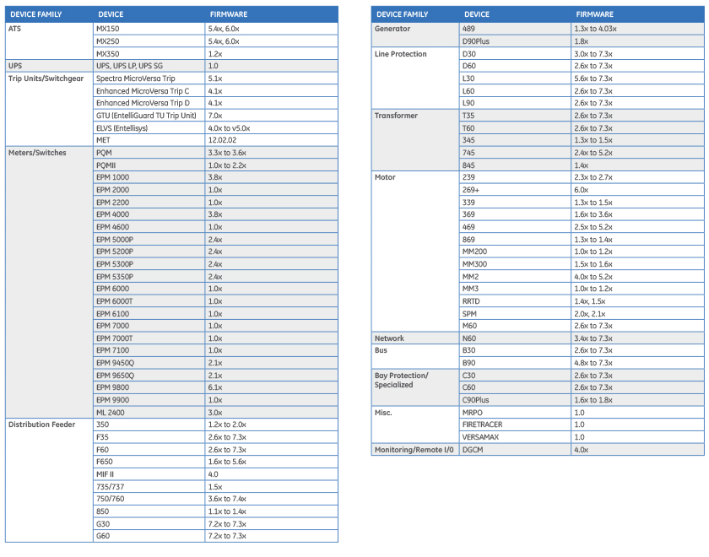
*EPM1000 and EPM4000 are not available in the IED Dashboard.

